**SPRINT-2**

|  |  |
| --- | --- |
| **Date** | **7 November 2022** |
| **TEAM ID** | **PNT2022TMID21685** |
| **Project Name** | **IoT Based smart crop Protection system for agriculture** |
| **Maximum mark** | **20 marks** |

**STEP1: Download and Install NODE JS.**

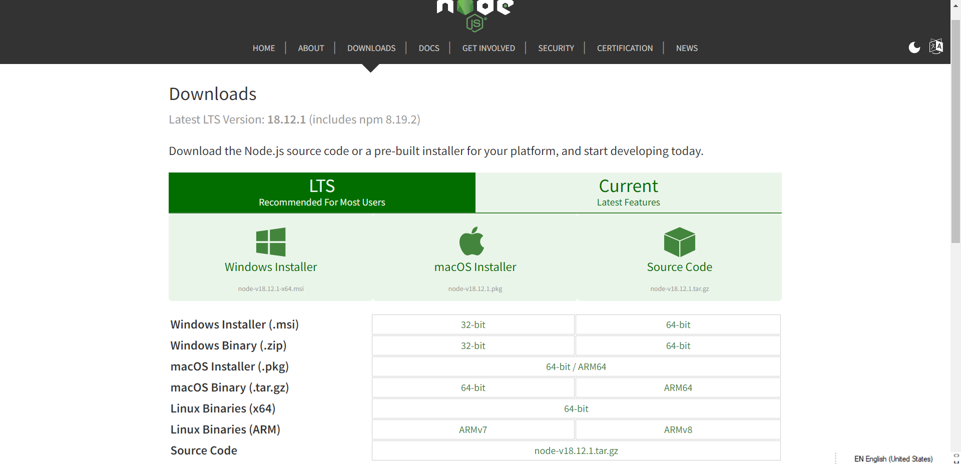

**STEP2: Setup node.js and configure command prompt for error check.open node-red from the generated link.**

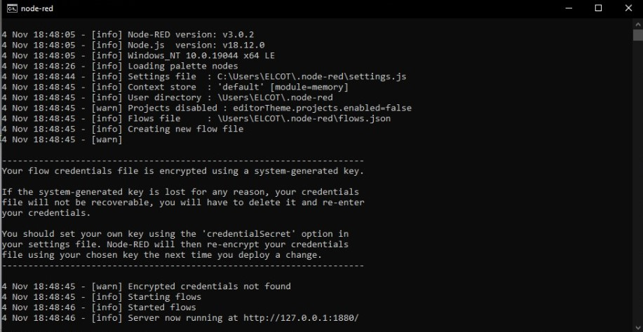

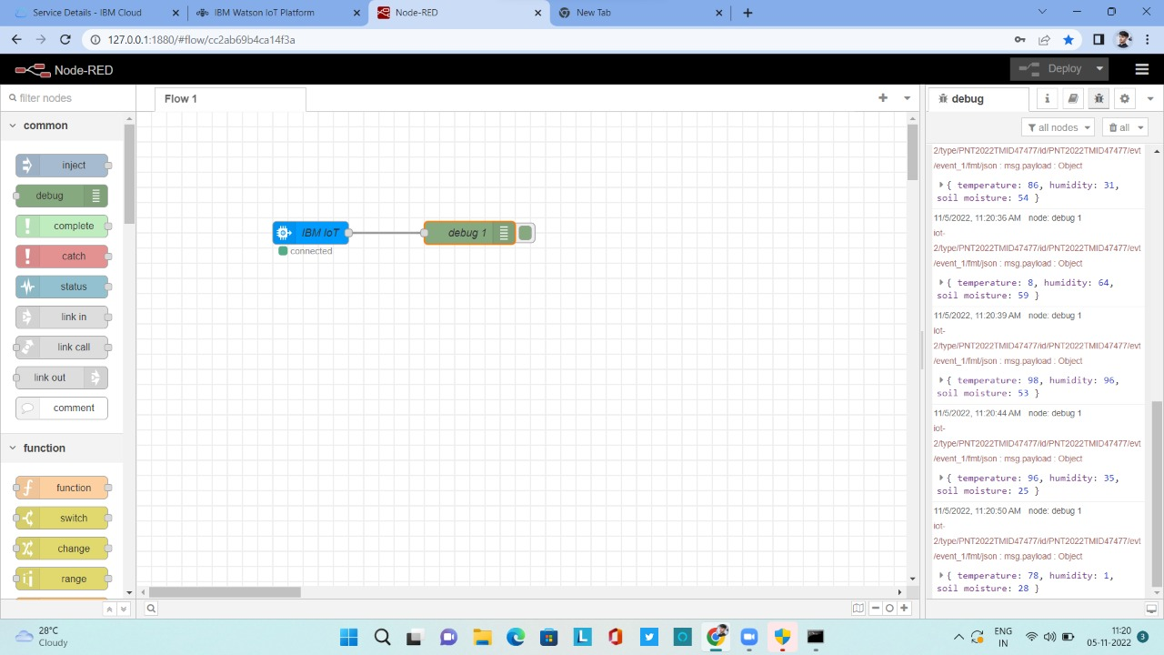**STEP3: Connect ibmiot in and Debug 1 and Deploy.**

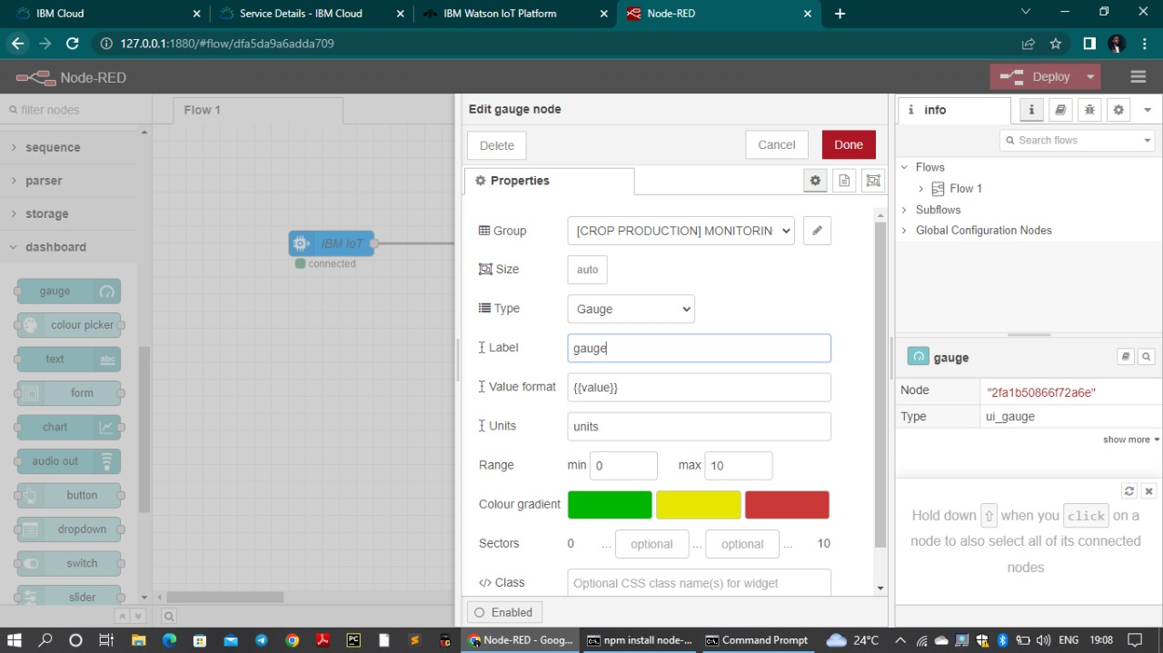**STEP4: Edit gauge node (Here the gauge nodes are named as Temperature, Humidity and Soil moisture).**

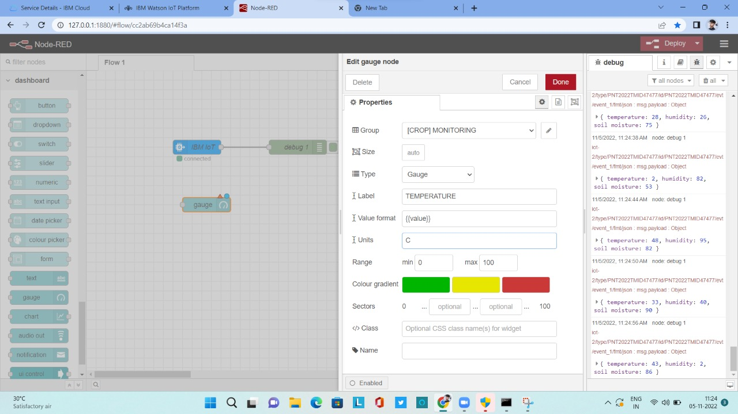

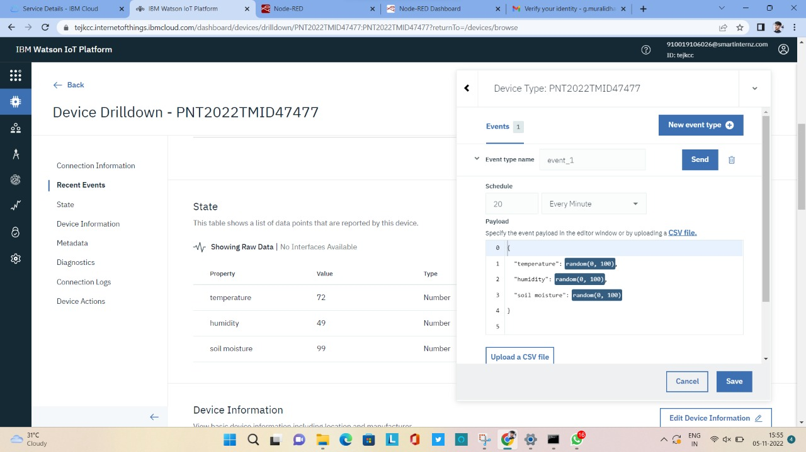**STEP5: Simulated program to get the random values.**

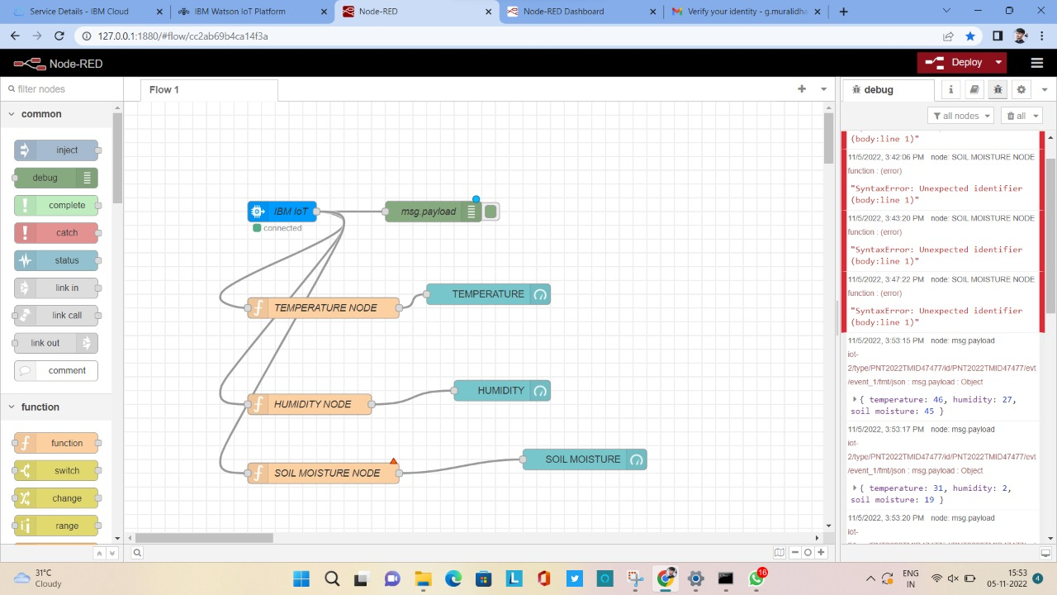**STEP6: Generate debug message from IBM Watson IoT Platform and connect the nodes.**

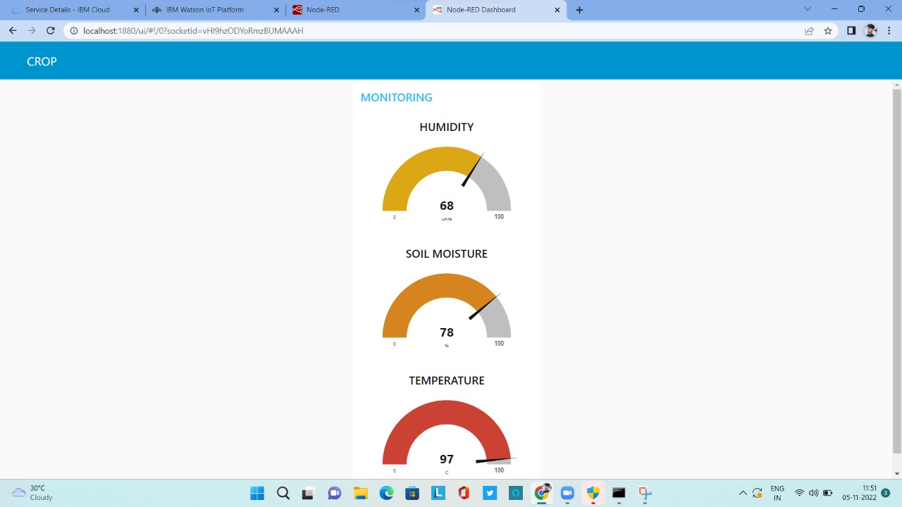**STEP7: Generate the some output from recent events.**

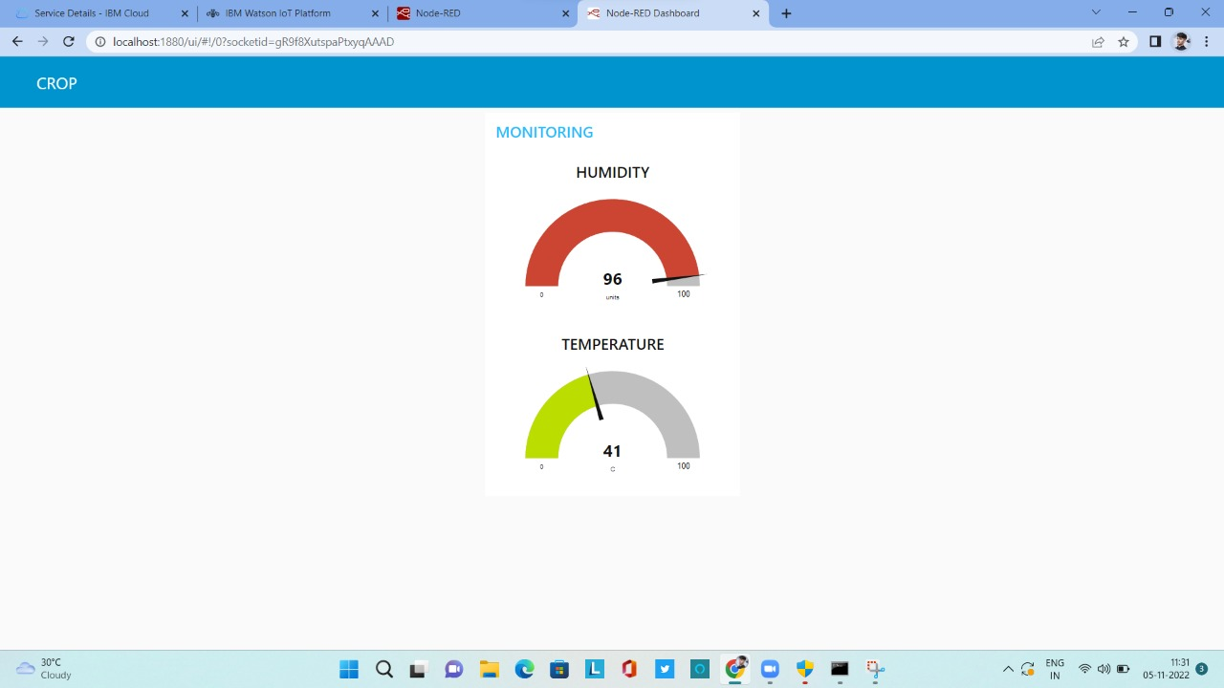

**STEP8: MIT APP inventor to design the APP.**

